Installation

Control Panel


Manual Setting

When the Control Panel run and connect to the MasterSonic generator, the active
set of generator parameters that are in its memory are automatically transferred to the control panel and show as current status

Central Operating Frequency of the ultrasonic generator
To set Operating Frequency – select desired parameter with LEFT and RIGHT pointer on the frequency slide, or with numeric keyboard. Latest value downloads to the generator immediately and automatically.
In case of your system always set the central operating “Frequency DDS” to the frequency marked on the acoustic load. Type numeric or using your mouse slowly change the frequency in 1 Hz steps to find the best central frequency point for every new test environment. Experiment until reaching the highest input power by noting the DC Power indicator in the lower right section of the PC control window. As you pass through the best central operating frequency the higher system efficiency is exhibited by improved DC Power delivery.

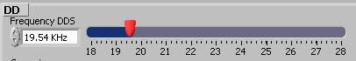

To set Sweeping Frequency - select desired parameter with LEFT and RIGHT pointer on the Sweeping slide, or with numeric keyboard. Latest value downloads to the generator immediately and automatically.
Then set “Sweeping” to minimum value or to zero (for instance to less than 0.1 kHz). As above, find the best interval by slowly sweeping across this defined range. The Best setting is when the input system DC Power is maximized, providing that System is producing uniform and continuous sound, without whistling, impulsive, non-periodical and cracking noise.

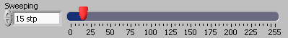

The power of the generator as a percent of the nominal power.
To Out Put Power - select desired parameter in full range percent with LEFT and RIGHT pointer on the power slide, or with numeric keyboard. Latest value downloads to the generator immediately and automatically.

Click on the Power Tab at the top of the PC Interface Control Software and set the input “Power” between 20% and 30% (preferably minimum value) by moving the sliding bar to the left position to max. 30%. This is to ensure that during regulations and settings generator would produce low power output, in order to avoid damaging mechanical system. Do not activate the generator
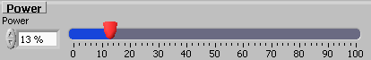

To set the Ultrasonic Power - select desired parameter in full range percent with LEFT and RIGHT pointer on the US power slide, or with numeric keyboard. Latest value downloads to the generator immediately and automatically.
Set the output “US Power” between 10 and 100 (preferably minimum value). This is to ensure that during regulations and settings generator would produce very low power-output in order to avoid damaging mechanical system. Do not activate the generator.

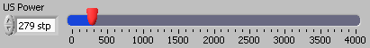

The amplification coefficient in the Fast Sweeping range of the Central Operating Frequency
To Fast Sweeping - select desired parameter in full range percent with LEFT and RIGHT pointer on the Fast Sweeping slide, or with numeric keyboard. Latest value downloads to the generator immediately and automatically.
Set the “FSWM range” to minimum or zero value (for instance to 0.070 kHz). Start with 0.000 kHz and later experiment by going higher until reaching maximum input DC Power, or best ultrasonic processing effects.

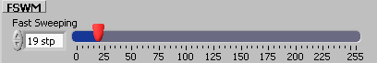

PWM Period duration at operation in ON/ OFF mode of the generator.
To set PWM Period - select desired parameter in full range percent with LEFT and RIGHT pointer on the PWM Period slide, or with numeric keyboard. Latest value downloads to the generator immediately and automatically.
Set at its minimum 0.010 s setting to start. When the PWM ratio is set to less than 100%, you may experiment by increasing it until 0.100 s), while reducing the Power in order to avoid pulsed over-current.

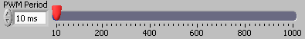

The ON period as a percent of the PWM Period.
To set PWM Period - select desired parameter in full range percent with LEFT and RIGHT pointer on the PWM Period slide, or with numeric keyboard. Latest value downloads to the generator immediately and automatically.
Keep at 100% until more experience is gained in using this system. When you are fully aware of all parameters and safe operation conditions you may reduce the PWM ration to 20% to realize low frequency pulsing (ON – OFF) liquid processing regimes.

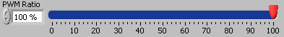

Voltage and Current phase difference- from 0 to 1000 unit, this item vary upon frequency and at the ultrasonic transducer resonance is near 500.
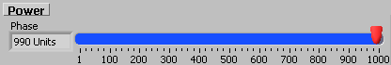

DC Current -
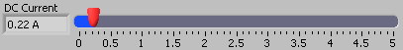

Tracking range- show generator frequency tracking to find the best central frequency of the transducer
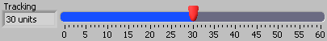

???????
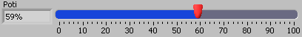

/?????????????
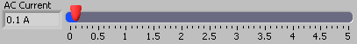

Output Voltage- The voltage generator act on the transducer
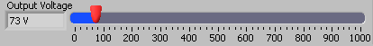

??????
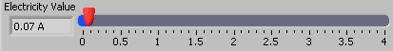

COM Port Selection – As the generator protocol is RS485 , You must use RS232⬄RS485 adaptor
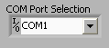

MODE: Asynchronous
DATA: 8 data bits
Stop: 1
Baud rate: 19200
Parity: No
Txd - 1 = Send
Rxd - 0 = Receive

ON/OFF Button – Click this button to turn on the generator. Enter is the Short key.
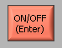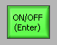

Exit – Click this button to exit from the PC interface. by click this b



Find Frequency Tab- to find ultrasonic system behavior vs. frequency. The PC control panel sweep frequency upon ultrasonic system and same output parameter from transducer and show them to make a decision for the best condition. this option reduce time and cost to find optimum frequency.

Frequency Range - set the band width you want to sweep frequency. by mouse or lower and upper frequency limit number.
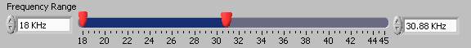

Power – set the generator output power during sweeping. the maximum power should be under 30%
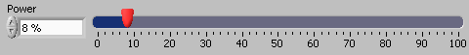

Frequency Step Size – set the frequency jump value in each step. To save time at the primary test set this value a little rough to find overall regime and then decrease sweeping band width and frequency step size to search parameter by higher resolution.
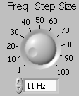

Delay Time – Set the time delay for frequency interval, to eliminate transient time and parameter. for large ultrasonic systems set this value higher.
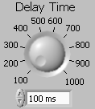

To avoid any mistake this button short key is "Ctrl+F5" to turn on generator and start sweeping and |"F5" to stop.



To show each item click select radio button and set amplification factor to magnify desired curve. these values let you to show several curve with each other and compare result better.
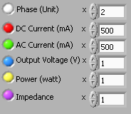

Save data / Load Data - To save and load achieved curves on the desired Path.
